Computer Science 220L
Laboratory 3 –Arithmetic, Loops
Learning Objectives:
- Develop simple Python programs that do input, produce output and do arithmetic using loops.
- Develop simple Python programs that use for loops.

Directed Activities:
0. Download lab3.py. Demonstrate each of your solutions for the instructor.

- Finding an average
Write a function, average(), that asks the user the number of grades to input. The function should then ask for each grade and output the average. The message to the user should be:
Enter your grade on HW1:
Enter your grade on HW2:
…

- Fibonacci.
A Fibonacci sequence is a sequence of numbers where each successive number is the sum of the previous two. The classic Fibonacci sequence begins: 0, 1, 1, 2, 3, 5, 8, 13, …. Write a function, fibonacci() , that computes and outputs all of the Fibonacci numbers up to and including the nth number, where n is a value input by the user.

- Compute a square root. (Adapted from the text, p. 78, Exercise 17)
Write a function newton() that approximates the square root of a number using Sir Isaac Newton's method. Ask the user what the number, x, is and how many times to improve the approximation. x / 2 is a good first approximation. Given an existing approximation,
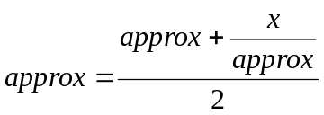

is a better approximation. Display the number and the final value of the approximation.

4. Draw a house
Write a function, buildHouse(), that uses the author’s graphic package to create a blue background with a white square house and a brown triangle roof. The house should be in the middle of the window. Use Rectangle class to build the house. Use Polygon to build the triangle.

5. Output a sequence
Write a function, sequence(), that asks the user for the number of terms in a series, then prints the following pattern for the appropriate number of terms.

1 3 3 5 5 7 7 9 9 …

6. Computing pi.
Write a function pi() that approximates the value of using the Wallis formula:
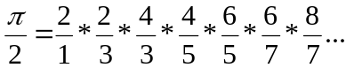

The program should prompt the user for n, the number of terms in the series, compute the product of the n terms, and output the resulting approximation of pi.

- Upload the file to your OAKS account. lab3.py If you left any files on the desktop, remove them. Log off of your computer.

